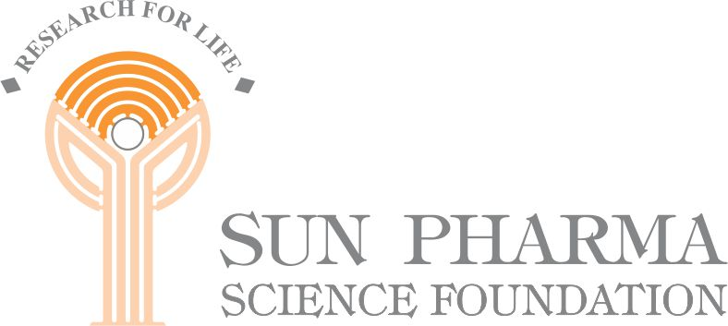

Sun Pharma Science Foundation Research Awards

Scope of the Awards

- Medical Sciences

a. Basic Research

Basic Research would cover :

◊ Fundamental advances in any discipline of physical or bio-medical sciences that enhance the understanding and scope of Medical Sciences.

b. Clinical Research

Clinical Research would cover :

- Contributions for better understanding of the functioning of human body system or aetiopathogenesis, pathophysiology or molecular basis of disease processes, thereby enhancing the understanding of medical sciences and lead to improvement in health care.

◊ Epidemiological studies on (a) prevalence of diseases, (b) impact of interventions on disease patterns in the community.

◊ Application of advances in Laboratory Methodology to enhance patient care.

◊ Advances in diagnosis and treatment of diseases.

◊ Advances in knowledge by clinical evaluation of new and existing drugs, vaccines and diagnostic tests.

◊ Epidemiological studies on the secondary prevention of diseases by therapeutic interventions.

The number of awards in each category could vary.

- Pharmaceutical Sciences

Pharmaceutical Sciences would cover :-

(i) New Drug Discovery and Development
- Design and development of new drugs
- Identification of new drug targets
- drug-receptor interaction and characterization of receptors
- Novel drug delivery systems
- Study of mode of action of drugs

(ii) Process Development and Applied Research
- Outstanding achievements in molecular biology, biotechnology and fermentation.

This would also include Applied Research in Pharmaceutical Science covering innovations in the applied field with distinctive features in :

- Development of new process technology for commercial production of active pharmaceutical ingredients, intermediates or excipients.

- Development of Pharmaceutical dosage forms with improved stability and/or bioavailability.

- Development of standardized dosage forms through exploitation of rich natural resources including from herbal sources and traditional systems drugs.

- Applied Research in the area of biotechnology/fermentation technology.

Outstanding contributions in one or more areas of the above categories would be eligible for an award.

